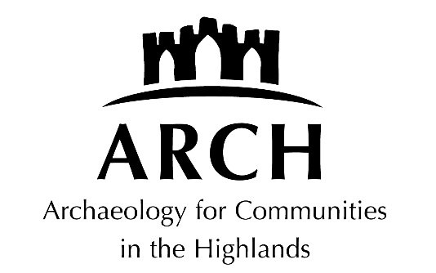

Checked and approved: July 2021, 2024

POLICY STATEMENT ON RECRUITMENT OF EX-OFFENDERS

The following definitions apply to this document:
1. Board members: members appointed to ARCH board;
2. Employees/staff: paid individuals who undertake work for ARCH on behalf of the company;
3. Volunteers: unpaid individuals who help run events on the company’s behalf; and
4. Members of the public: members of the public who attend ARCH events.

Statement

We will treat any applicant for any position within our organisation (paid or voluntary) fairly and will not discriminate unfairly against the subject of a disclosure on the basis of conviction.

We will request a Standard or Enhanced disclosure only where it is necessary and relevant to the position sought.

Where a position requires a disclosure we will make this clear on the application form, job advert and any other information provided about the post.

At interview we will ensure that open and measured discussions can take place on the subject of offences.

Failure to reveal information at interview, that is directly relevant to the position sought, could lead to withdrawal of an offer of employment.

At interview or when receiving a disclosure which shows a conviction or which contains intelligence of significance to working with children and families, we will use our professional judgement and take into consideration:

- Whether the conviction/intelligence is relevant to the position being offered.

- The seriousness of the offence revealed.

- The length of time since the offence took place.

- Whether the applicant has a pattern of offending behaviour.

- Whether the applicant’s circumstances have changed since offending took place.

We will ensure that all Board members, staff or volunteers involved in the recruitment process are aware of this policy and have received relevant training and support.

Any applicant for any post that requires a disclosure may receive a copy of this policy and the Code of Practice.

